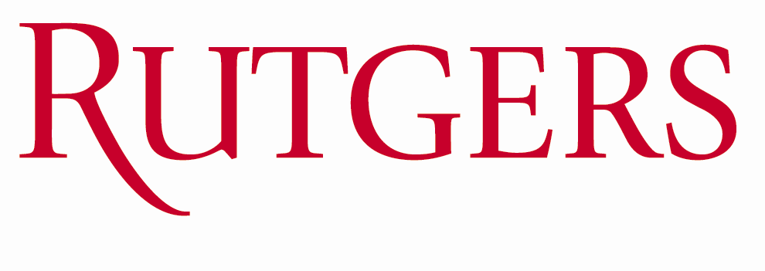

**Travel and Business Expense Report**

**Instructions/Purpose:** The employee or visitor must complete this form when reimbursement is being requested. The completed and signed Travel and Business Expense Report (TABER) form with all appropriate receipts attached should be submitted after **department approval** to Accounts Payable, ASB, Room 302, 65 Davidson Road, Piscataway, NJ 08854, Busch Campus. If this form is printed, **please type or print legibly in BLACK ink.**

Department Reference Field (optional):        Employee  Visitor

|  |  |  |  |
| --- | --- | --- | --- |
| Traveler Name:  Malin Pinsky | Rutgers Employee ID#: | | Request Date:  7/28/2106 |
| Traveler Mailing Address: | | Traveler Phone Number: | |
| **Note: Active Rutgers University employees will receive reimbursements in their paychecks. Otherwise, checks will automatically be mailed to the above address unless one option below is selected:**  Call for Check Pickup:  (First Name, Last Name, Campus Phone Number)  Send Check to Approver’s Location:  (First Name, Last Name)  Send Check to Preparer’s Location:  (First Name, Last Name) | | | |

|  |  |  |  |  |  |  |
| --- | --- | --- | --- | --- | --- | --- |
| **Date** | | **Description** | | | **Mileage** | **Amount** |
| 7/26/2016 | | Dinner at Shanghai Park Restaurant | | |  | $198.55 |
|  | |  | | |  |  |
|  | |  | | |  |  |
|  | |  | | |  |  |
|  | |  | | |  |  |
|  | |  | | |  |  |
|  | |  | | |  |  |
|  | |  | | |  |  |
| Please Explain the Reason or Purpose of Business Reimbursement: (Required) | | | | Total Amount | | $198.55 |
|  | | | | Less Amount Disallowed | |  |
|  | | | | Reimbursable Expenses | | $198.55 |
|  | | | | Less Cash Advances | |  |
|  | | | | Amount Due Traveler  (or University) | | $198.55 |
| Traveler’s Signature: |  | | Approver’s Signature: |  | |  |
| Campus Phone Number (Approver): |  | | Print Approver’s Name: |  | |  |

|  |  |  |  |  |  |  |
| --- | --- | --- | --- | --- | --- | --- |
| Account Distribution (required) | | | | | | |
| Fund Source (Account) | Organization | Natural Account | Department Activity 1 | Department Activity 2 | Amount | |
| 437684 |  |  |  |  | $198.55 | |
|  |  |  |  |  |  | |
|  |  |  |  |  |  | |
|  |  |  |  |  |  | |
| **Revised May 12, 2014** |  |  | Advance Amount | | |  |
|  |  |  | Reimbursement Amount | | | $198.55 |